ELEN 50L Lab Report 5
Yutong Li and Zenichi Yaskawa Project 1 F 2:15 PM
Project 1: Optimal Power Delivery
Introduction:
Through this lab, we learned how to calculate Thevenin resistance, voltages, powers, and other electric values. We also used matrices, plots, and various other functions inside MATHLAB. We were also able to calculate the maximum and efficient power from a variable resistor. Furthermore, we were able to apply our theoretical knowledge from ELEN 50 to the lab, which was pretty awesome! ☺
Problem 1 1
Problem 2 2
Problem 3 4

Problem 1
Find a Thevenin equivalent with respect to R9 to find the maximal power that R9 absorbs.
% Assigning Variables
R1 = 1000;
R2 = 1000;
R3 = 1000;
R4 = 500;
R5 = 500;
R6 = 500;
R7 = 500;
R8 = 1000;
%R9 = variable;
R10 = 500;
Vg = 12;
% Used Matrices to calculate Voltages
A = [-1/R3, 1/R3+1/R5+1/R4+1/R10, -1/R4, 0, -1/R5;
-1/R1, 0, -1/R6, 1/R8+1/R1+1/R6, -1/R8;
-1/R2, -1/R4, 1/R2+1/R4+1/R7+1/R6, -1/R6, -1/R7;
0, -1/R5, -1/R7, -1/R8, 1/R7+1/R8+1/R5;
1, 0, 0, 0, 0;];
B = [0; 0; 0; 0; 12];
V1 = A\B
Vth = V1(5)
% Matrice calculation with deactivated voltage source
C = [ 1/R3+1/R5+1/R4+1/R10, -1/R4, 0, -1/R5;
0, -1/R6, 1/R8+1/R1+1/R6, -1/R8;
-1/R4, 1/R2+1/R4+1/R7+1/R6, -1/R6, -1/R7;
-1/R5, -1/R7, -1/R8, 1/R7+1/R8+1/R5;];
D = [0; 0; 0; 1;];
V2 = inv(C)*D;
Rth = V2(4)/1
% Calculation of R thevenin
RL = Rth
% Calculation of Power in R9, R10
PR9 = (V1(5))^2/RL;
PR10 = (V1(2))^2/R10;
r = PR9/PR10;
% Calculation of efficiency, power and current
Ig = (V1(4)-V1(1))/R1 + (V1(3)-V1(1))/R2 +(V1(2)-V1(1))/R3;
Pg = Ig*Vg;
k = (PR9 + PR10)/Pg;
V1 =
12.0000
6.2426
8.2480
9.0243
7.6011
Vth =
7.6011
Rth =
409.7035
RL =
409.7035

Problem 2
Compute P9, P10 and the efficiency coefficient in order to plot graphs for different values of R9.
% Using matrices for calculation
G1 = [-1/R3, 1/R3+1/R5+1/R4+1/R10, -1/R4, 0, -1/R5;
-1/R1, 0, -1/R6, 1/R8+1/R1+1/R6, -1/R8;
-1/R2, -1/R4, 1/R2+1/R4+1/R7+1/R6, -1/R6, -1/R7;
0, -1/R5, -1/R7, -1/R8, 1/R7+1/R8+1/R5;
1, 0, 0, 0, 0;];
G2 = [0, 0, 0, 0, 0;
0, 0, 0, 0, 0;
0, 0, 0, 0, 0;
0, 0, 0, 0, 1;
0, 0, 0, 0, 0;];
b = [0; 0; 0; 0; 12;];
R9 = [10:10:1e5];
% Calling the function
[eta,P9,P10] = powerdeliv(G1,G2,b,R9);
% Plot for Power P9 and P10 of R9 and R10
figure(1);
semilogx(R9, P9, 'g', R9, P10, 'r');
title('Powers P9 and P10 as functions of R9');
xlabel('Resistance R9')
ylabel('Powers P9 and P10')
legend('green is R9', 'red is R10')
% Plot for efficiency
figure(2);
semilogx(R9, eta);
title('The efficiency coefficient eta as a function of R9');
xlabel ('Resistance R9')
ylabel ('Coefficient ETA')
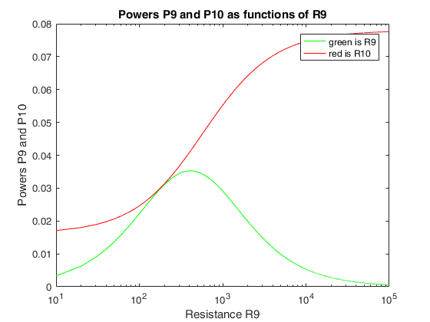
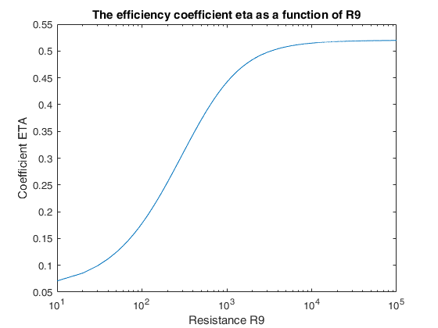

Problem 3
Select R9 so that eta is maximized with the following constraint: P9/P10 is less than or equal to 1.3 and greater than 0.7
R = [10:10:1e5];
for i = 1:length(R)
ratio = P9(i)/P10(i);
% Restricting ratio between 0.7 and 1.3
if ratio <=1.3
if ratio >0.7
eta_new(i) = eta(i);
else
eta_new(i)=0;
end
else
eta_new(0) = 0;
end
end
% Plot of R9 maximized with 0.7 < P9/P10 < 1.3
figure(3);
semilogx(R9, eta_new)
% by looking at the maximum of the graph, the maximum value is 630
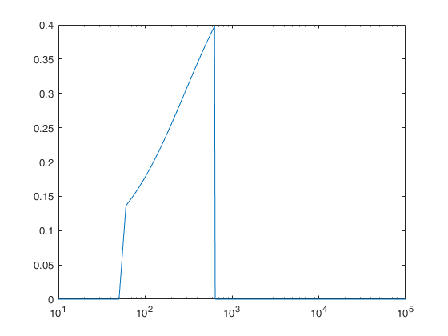

PROBLEM 4:
Plots for P9, P10 and efficiency from measured values
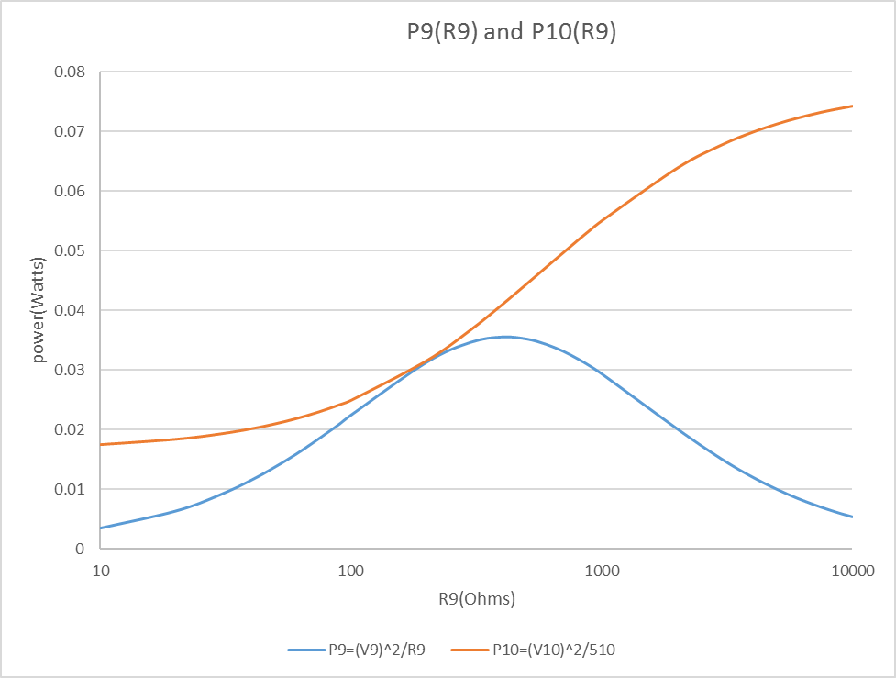

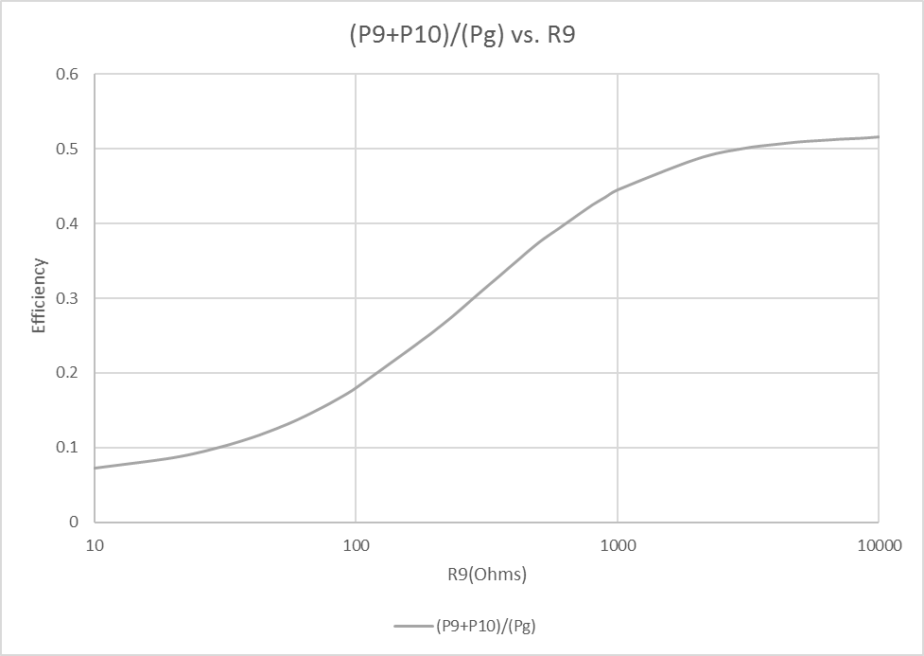
Published with MATLAB® R2016a
Conclusion:
Through this lab, we learned how to use various functions of MATHLAB and also understand how variable resistance affects power generated by components. The graphs created theoretically (Problem 3) matches the measured/actual (Problem 4), which means that our values and calculations were correct. Furthermore, we also calculated the variable resistance as 630 Ohms to be the one that gives the maximum efficiency of the powers. All in all, we learned a lot from this lab.

